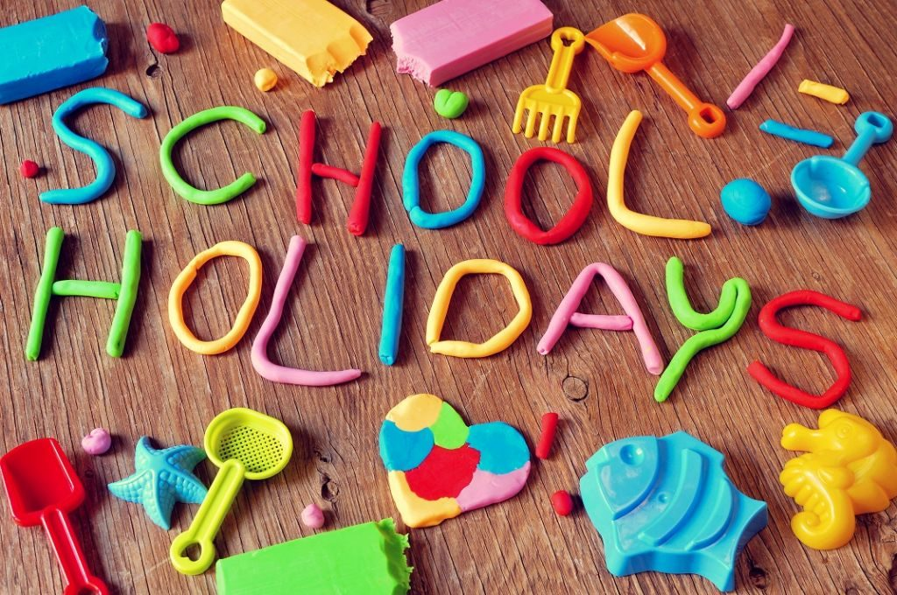
2023

The Growing Place is closed for the following holidays:
Martin Luther King Jr Day – January 16th
Memorial Day – May 29th
4th of July – July 4th
Labor Day – September 4th
Thanksgiving: November 23rd &24th
Christmas: December 25th

The Growing Place is closed for the following teacher/classroom enhancement dates:
November 22nd
*Dates in May and August are TBD based on school district schedules*

